# 發票對獎系統

index.html：送出樞紐導頁到

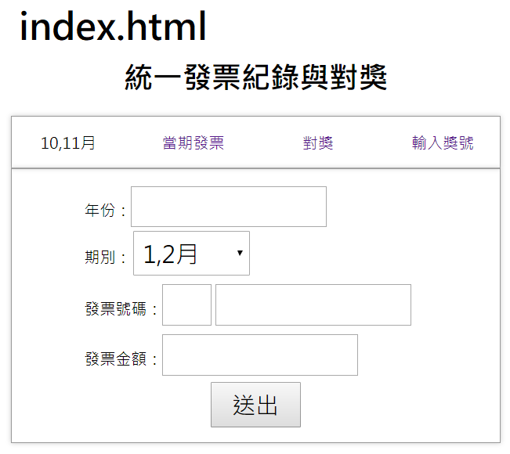

api/recevie_invoice.php

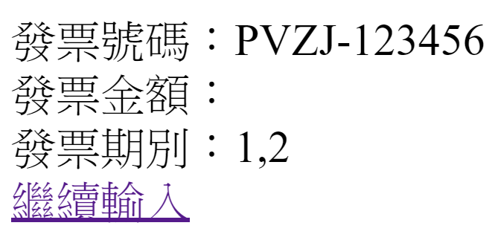

繼續輸入，導回index.html。

invoice_list.php

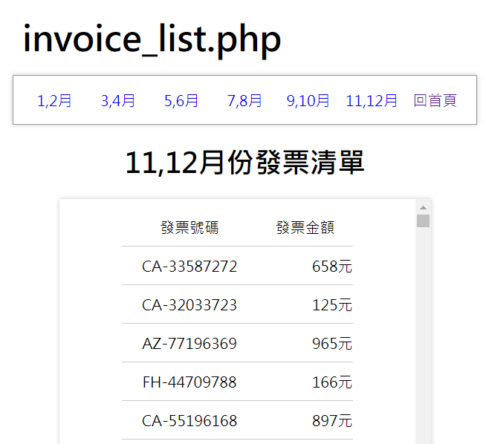

query_award.php?year=2019&period=2

query_award.php?year=2019&period=6

對獎樞紐導頁到query_award.php

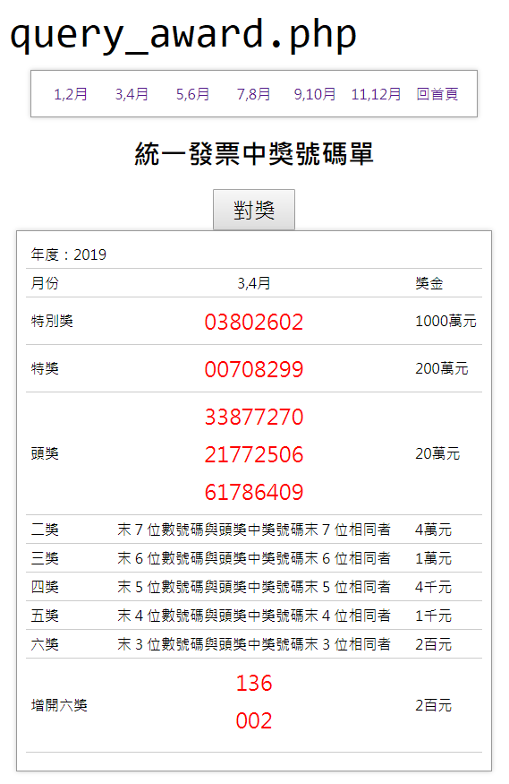

award.php?year=2019&period=2

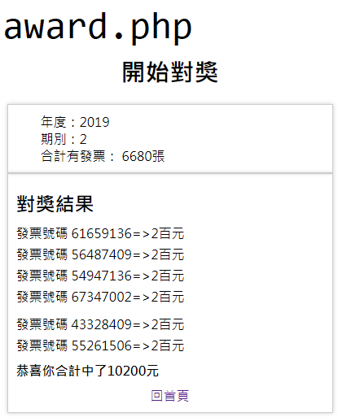

award_numbers.html

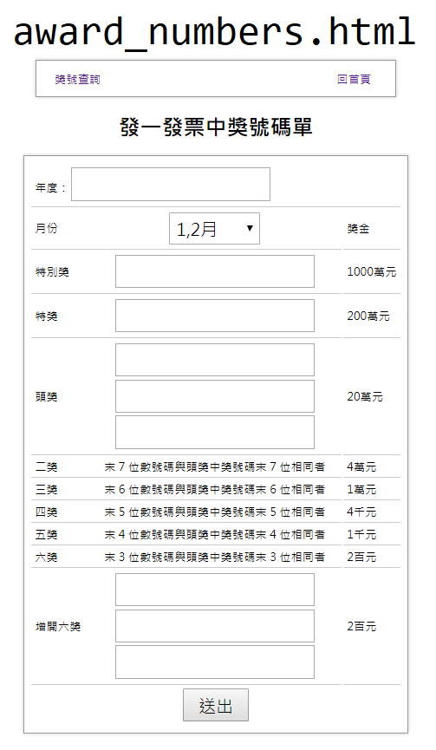

# -end-